<Project Name>

Software Design Document (SDD)

Version <1.0>
<Date>

[NOTE: REMOVE OR REPLACE WITH THE NECESSARY TEXT OF ALL RED-COLORED TEXT OR FIELDS IN THE DOCUMENT.]
[NOTE: USE JUSTIFIED TEXT FORMATTING. ALWAYS USE FULL SENTENCES WITH PROPER USE OF FORMAL LANGUAGE.]
[NOTE: USE FULL SENTENCES THROUGHOUT THE DOCUMENT INCLUDING THE TABLES.]
[Note: Text enclosed in square brackets and displayed in blue italics (style=InfoBlue) is included to guide the author and should be deleted before publishing the document. A paragraph entered following this style will automatically be set to normal (style=Body Text).]
[To customize automatic fields in Microsoft Word (which display a gray background when selected), select File>Properties and replace the Title, Subject, and Company fields with the appropriate information for this document. After closing the dialog, automatic fields may be updated throughout the document by selecting Edit>Select All (or Ctrl-A) and pressing F9, or simply clicking on the field and pressing F9. This must be done separately for Headers and Footers. Alt-F9 will toggle between displaying the field names and the field contents. See Word help for more information on working with fields.]

Release Checklist

[Review the document for each checklist item and mark it as YES or NO.]

Checklist Item | Control (Yes/No)
The document has passed the quality assurance process. | YES / NO
The document is visually appealing and has a professional look and structure. | YES / NO
All placeholders such as text within <> are replaced with appropriate text. | YES / NO
The document is prepared in the “Justify Text” format. | YES / NO
The document does not include typos, different fonts, and misalignments. | YES / NO
In the revision history, the first version states “The first version”. Additional versions include an entry highlighting all the changes from the previous version. | YES / NO
The table of contents (TOC) is updated as necessary. | YES / NO
References list other project documents and additional standards or documents needed to understand the document. The references include the necessary document/artifact version number and publication date. | YES / NO
The language grammar is used appropriately. | YES / NO
Sentences are written as full sentences. | YES / NO
The wording in the document is formal. | YES / NO
The wording in the document is clear. | YES / NO
The wording in the document is professional. | YES / NO
All project-related definitions, acronyms, and abbreviations sections are included in the related tables. | YES / NO
The team member names are specifically spelled out in the document preparation and approvals sections. | YES / NO
The purpose and scope of the document are adequately described. | YES / NO
All sections include the necessary and adequate information. | YES / NO
The design decisions, design constraints, and the related reasonings are written in full sentences. | YES / NO
The system designs are provided in such detail to guide the remaining development process.
The user interface designs are provided in such detail to guide the remaining development process. | YES / NO
The modules are described with adequate descriptions. | YES / NO

Final Control | Yes/No
The document is checked based on the “Team Project Artifacts Common Errors” Guideline. The document is ready for release. | YES / NO
The document is not ready for release. | YES / NO

Document Preparation
Name | Role | Approval (Signature) | Approval Date
<name> | <Project Design Engineer> | <Signature> | <mm/dd/yy>
<name> | <Project Design Manager> | <Signature> | <mm/dd/yy>

Document Approvals
Name | Role | Approval (Signature) | Approval Date
<name> | <Project Technical Manager>  If one of the specific roles is not present, that role may be deleted. | <Signature> | <mm/dd/yy>
 | <Project Configuration Manager>
 | <Project Test Manager>
 | <Project Requirements Manager>
 | <Project Manager>
 | <Project Sponsor>

Revision History
Date | Version | Description | Author
<mm/dd/yy> | <x.x> | <details> | <name>  Individual team member/s names should be listed. The company or the team’s name should not be listed.

Table of Contents
1. Introduction 6
1.1 Purpose of the Document 6
1.2 Scope of the Document 6
1.3 References 6
1.4 Definitions, Acronyms, and Abbreviations 6
2. Product Scope 6
3. System Design Decisions and Constraints 7
3.1 System Design Decisions 7
3.2 System Design Constraints 8
4. Software Architectural Design 8
5. Software Design - Modules/Classes 9
5.1 Module Name 9
5.2 Module Name 9
5.3 Module Name 9
6. User Interface Design 9
7. Appendix A – Class Diagram of the Software System 10
8. Appendix B – User Interfaces 12

Software Design (SDD)

Introduction
[The introduction of the software design document provides an overview of the entire document.]

Purpose of the Document
[The purpose of this document is to document the software design for the project [name].]

Scope of the Document
[This subsection provides an overview of the entire document.]

References
[This subsection provides a complete list of all project-related documents within the project and other documents necessary to understand this SRS. List the project and other related documents with their publication date and version number.]
Reference Title/Name | Date | Version
Project Description Document | 08/15/2024 | 2.0
Project Vision Document (PVD) | 09/13/2024 | 1.0
Project Plan (PP) | 09/20/2024 | 1.0
IEEE/ISO/IEC 29148-2018 - ISO/IEC/IEEE International Standard - Systems and software engineering -- Life cycle processes -- Requirements engineering | 10/23/2018 | 2018
Web Content Accessibility Guidelines (WCAG) | 11/11/2008 | 2.0
… | … | …

Definitions, Acronyms, and Abbreviations

Term | Abbreviation / Acronym | Definition

Product Scope
[Briefly describe the scope of the product. In addition, you may specify what is out of scope for this product. If the product scope has not changed at this point, you may reuse the product scope sections written in the previous project documentation. If the product scope has changed at this point, then the new product scope should be described here and the previous documents should be updated based on the new product scope. Note that all project documents should be consistent.]

System Design Decisions and Constraints

System Design Decisions
[Present a list of all design decisions. The design decisions are the decisions you make about the product. They are not constraints but choices. The design constraints have their own section. The design decisions should be written in full sentences. At the very basic, there should be at least 3-4 design decisions.]
System Design Decision ID | Date | Design Decision | Reason
DD-1 | MM/DD/YYYY | Briefly describe the design decision using a full sentence. The design decision could be written in one or two sentences.  Some example design decisions are provided. | Briefly describe the reason for the design decision using full sentences. Documenting the reason for the design decision is important. When the reason for the specific decision changes, it is important to revisit the design decision to make sure that the decision is still valid and necessary.
DD-2 | 09/01/2024 | The application shall be a mobile application. | This application is an application that a user may use at any time. Furthermore, the need for the application is frequent. As users will have their smartphones with them almost at all times, the decision to make the application mobile will increase the use and adoption of the application.
DD-3 | 09/15/2024 | The application shall use icons in addition to text in the user interface whenever possible. | The application users have varying ages including teenagers and elders. To make the application user-friendly, the icons will help to recognize actions in the buttons quickly.
DD-4 | 10/02/2024 | The application shall use a database to store user data. | The user data will be needed across use sessions. In addition, several user interfaces will need to manipulate different types of user data. Having a database will ease to extract necessary data without the need to extract all data related to a user.
DD-5 | 10/02/2024 | The architecture of the application shall be model-view-controller architecture (MVC). | There are different types of users for the application. Each user type will have a different user interface. Therefore, decoupling the user interface from the model will increase the development speed. Therefore, there is a necessity to decouple the frontend from the backend.
DD-6 | 10/10/2024 | The application shall have a light and dark mode. | The application is a mobile application that can be used in the daytime and nighttime. Having appropriate modes will help the use of the application.
DD-7 | 10/15/2024 | The application shall use Python libraries for mathematical calculation. | The application includes many heavy calculations. As Python libraries support many different mathematical operations, using these libraries will speed up the development.
DD-8 | 10/20/2024 | The application shall use Java in the front-end development. | As Java is strong in user interface development, the use of Java will help to develop good user interfaces. In addition, most of the developers in the team are skilled in Java.

System Design Constraints
[Present a list of all design constraints. The design constraints are not by choice. They are the constraints that are imposed on the system design due to many reasons including customer requirements, the need to integrate into other applications, the hardware limitations, etc. There should be at least 3-4 design constraints. Note that these are system design constraints not project management constraints such as schedule or skill limitations.]
System Design Constraint ID | Date | Constraint | Reason
DC-1 | MM/DD/YYYY | Briefly describe the design constraint using a full sentence. The design constraint could be written in one or two sentences.  Some example design constraints are provided. | Briefly describe the reason for the design constraint using full sentences. Documenting the reason for the design constraint is important. When the constraint is changed or eliminated for any reason, it is important to revisit the design constraint to make sure that the design has more flexibility.
DC-2 | 09/01/2024 | The application shall be developed with Java. | The use of the Java programming language is part of the customer requirements.
DC-3 | 09/10/2024 | The application shall be a mobile application. | As the application use is expected to be ubiquitous, a mobile application is necessary. .
DC-4 | 09/15/2024 | The application shall not use more than 4 GB of memory space. | The internet of things (IoT) device enforced by the user can only have 6 GB of memory. The current operating system uses 2 GB of memory. Therefore, the application should work with a maximum of 4GB of memory.

Software Architectural Design
[You do not have to fill this section for the course project. You may just write the text below and move on to the next section.]
The software architecture of the [project/system name] is described in this section.

Software Design - Modules/Classes
[This section describes the software modules in the system. The overall software design is presented in relevant appendices. Provide a list of modules in the system. The minimum number of modules that are required are specified in the project description document.]
Module/Class Name | Module Short Name (If there is one) | Short Description of the Module/Class
Module Name | Short Module Name | Briefly describe the module using full sentences. The description could be provided in 2-3 sentences.
Login | Login | The login module is responsible for getting the user's login information and verifying the user data to allow login for the user. The login module interfaces with the database module to verify the user login information.
AI Interface | AI Interface | The AI interface module is responsible for integrating the application control module with the generative AI tools.

Module Name
[Describe the module here.]

Module Name
[Describe the module here.]

Module Name
[Describe the module here.]

User Interface Design
[This section describes the user interface design of the system. Explain the reasoning behind the design of the user interfaces. The sketches/prototypes of user interfaces are presented in the relevant Appendix.]

Appendix A – Class Diagram of the Software System
[Present the class diagram here. If it is not applicable, write Not Applicable. For some web applications, we may not have a class diagram. You may use UML Component Diagrams for such web applications.]
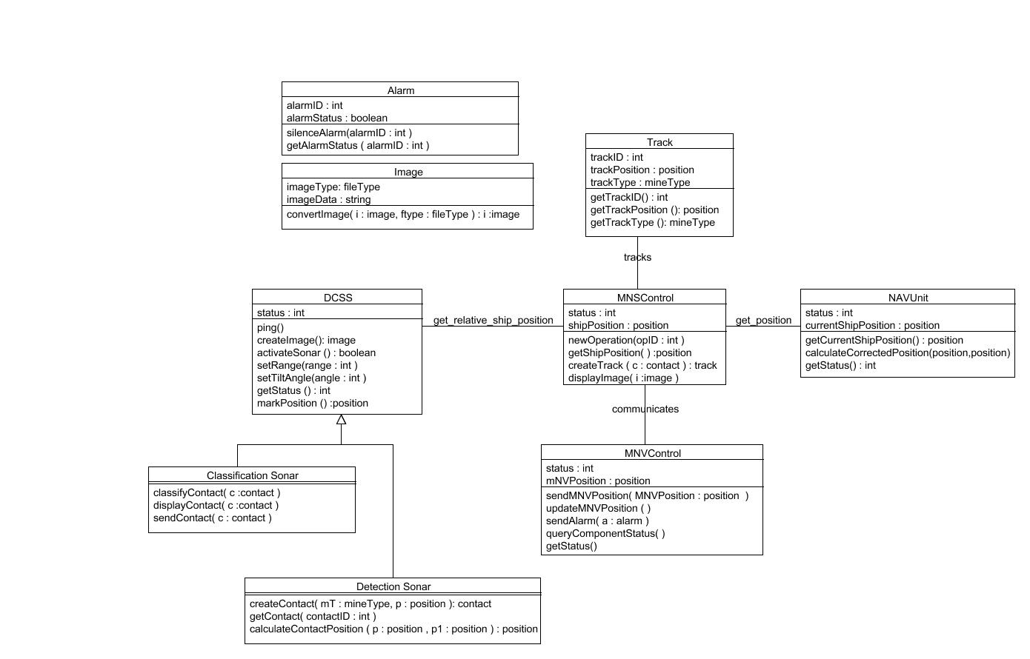

Appendix B – User Interfaces
[Present the user interfaces of the system. You may use applications for creating user interfaces. For example, CANVA. The user interfaces may be even sketches and designs in PowerPoint. If you developed the application, then these user interfaces should be the actual user interfaces.]

